BSL3 Rhapsody Protocol Day 1  8-Lane W/A/S/TB  Day 1: Load cartridge, Lyse & capture cells, cDNA/Template Switch  Prep Outside BSL3 (for 1 lane)  - Place everything on ice, transfer to cold block when entering  - Cell Capture Beads: Place on magnet, remove bead resus buffer, replace with 380uL cold sample buffer. Keep on ice  - Prepare Lysis buffer: aliquot 2mL Lysis buffer + 10uL 1M DTT. Invert and keep on ice  - Calcein & DRAQ7 aliquots  - SMK Ab cocktail: (for 1E6 cells)  - MHC1 SMK: 10uL + 1uL CD16/32 + 189uL Stain Buff  - CD45 SMK: 10uL + 1uL CD16/32 + 199uL Stain Buff  - Pipet mix, do not vortex!  - Abseq cocktail: (for 1E6 cells)  - 5 uL Fc block + 1 uL each AbO (x27) + 168uL Stain Buff  - Pipet mix, do not vortex! | Rhapsody Cart Load & Start  - Minimize time between cell pool and single cell capture  - Calculate pooling volumes for each sample  - Pipette mix gently then pool. Add Sample Buffer up to 340uL  - With cartridge on Express, Load Cells:  Pipette Material Volume (uL) Pipette Mode  P1200M Air 500 Prime/Treat  Set to Cell Load mode, manually pipette mix cells  P1200M Pooled cells 340 Cell Load  - Incubate cart @ RT 15mins  Counting Cart w/ Microscope  - Parafilm cart openings, decon and move to microscope  - Center using fiducial (post). Take note of number of wells in FOV  - note: if the count of CAlcein positive cells is <100, count cells in another field of view until Calcein count is >= 100  - $Viability=\frac{\# Calcin pos}{(\# Calcein neg+ \# PI pos)}$  - Estimate cell load. Total wells ~270,000  Load Cell Capture Beads  - Place cart on Express  - Bead Load:  Pipet Material uL Pipet Mode  P1200M Air 500 Prime/Treat  Manually pipette mix beads first  P1200M Capture Beads 340 Bead Load  - Gently rock cartridge briefly to increase bead load yield  - Incubate cart @RT 3mins  - Bead Wash:  Pipet Material uL Pipet Mode  P1200M Air 500 Wash  P1200M Cold Sample Buffer 500 Wash  P1200M Air 500 Wash  P1200M Cold Sample Buffer 500 Wash  - Optional count to check number of beads+cells  Lyse Cells & Bead Retrieval  - Incubate @RT 2 mins. Maintain recommended lysis time for best performance  - move front slider to BEADS and set pipet to retrieval mode  - At 2 mins end IMMEDIATELY slide magnet onto cart. Leave for exactly 30 sec  - Towards end of 30sec take up ~1mL Lysis Buffer  - After 30s, remove magnet and add Lysis  - Move front slider to OPEN and remove collection tube  - Proceed to Wash Cell Capture Beads  - Transfer retrieved volume to screwcap tube. Parafilm and decon for transfer out of BSL3  - Discard waste container. Clean and decon HT Express
IN BSL3
- Transfer reagents to cold block
Cartridge Prime & Treat:
- Open slider and check waste, load new collection tube
- Prime cartridge and leave for 1 min RT
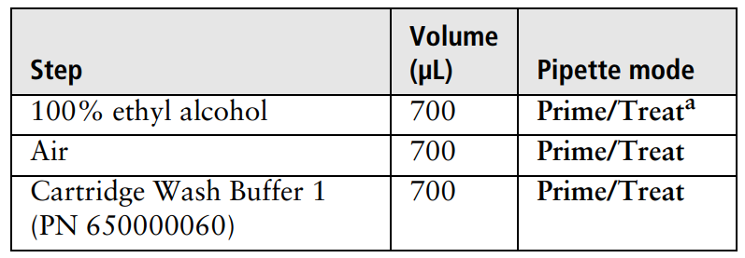
- Treat cartridge and use within 4 hours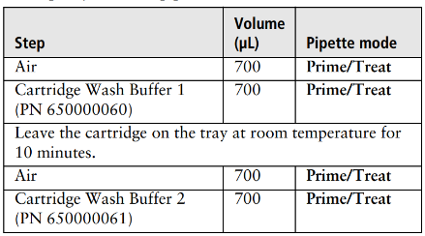
AbSeq & Sample Tag Stain
- Aliquot 5E5-1E6 cells, spin down 400g 5mins 4C
- Resuspend in 200uL SMK Ab cocktail. Incubate @RT 20mins
- Add ~500uL Sample buffer to resuspend
- Spin 400g 5mins, remove SN carefully
- Resuspend in 200uL Ab cocktail. Incubate on ice 30mins
- Add 1mL BD stain buffer and pip mix
- Spin 400g 5mins, remove SN carefully
- Resuspend 1mL Staining Buffer, 10uL cell count, no dilution
- Pool SMK’d samples for total of 150-200k cells, spin and carefully remove SN
- Resus in 620uL cold Sample Buffer
Cell Viability Stain
- Add 3.1 μL of 2 mM Calcein AM and 3.1 μL of 0.3 mM DRAQ7™, (1:200 dilution) gently pipet mix
- Incubate IN DARK @37°C
- Strain cells thru flow tube cap and immediately count
Keep cells in dark on ice!
Outside BSL3
Wash Cell Capture Beads
- Place 5mL tube on magnet for 1 min. Remove 4mL SN (leave 1mL)
- Gently pipet mix and transfer to 1.5mL LoBind tube
  - Can rinse with small volume Lysis Buffer
- Place on magnet for ≤2 mins. Remove all SN. AVOID BUBBLES
- Off magnet, add 1mL cold Bead Wash Buffer and mix
- Repeat wash for total of 2 cycles. Keep in buffer 2nd time
- Place on ice, start reverse transcription ≤30mins after wash
cDNA Synthesis & Template Switch
- Set thermomixer to 42°C
- Make cDNA/template switching MM keep on ICE
cDNA/temp switch mix | 1X (uL) | 1X+10% overage (uL)
RT Buffer | 40 | 44
dNTP | 20 | 22
RT 0.1 M DTT | 10 | 11
Bead RT/PCR Enhancer | 12 | 13.2
Rnase Inhibitor | 10 | 11
Reverse Transcriptase | 10 | 11
Nuclase-free H2O | 98 | 107.8
Total: | 200 | 220

- Place 1.5mL beads on magnet >2 mins. Remove SN.
- Add 200uL cDNA MM. Pipet mix and transfer to new tube
- Incubate on thermomixer 1200rpm @42°C for 30mins
  - During last 2mins make TSO mix:
6.3uL TSO + 2.1uL 1 M MgCl2 = 8.4uL total
- Once 30mins is up, add 8uL TSO mix and gently pipet mix.
- Incubate on thermomixer again 1200rpm @42°C for 30mins
- Place on magnet until clear, discard SN
- Remove from magnet and gently resus in 75uL Elution Buffer. DO NOT VORTEX!
Stopping point: can store Capture Beads up to 4-7 days at 2-8°C DO NOT FREEZE CAPTURE BEADS

